University of California,

Santa Barbara

CS48 Spring’17, G01 Project

**Arcade Haven**

Alnawakhtha, Yusuf

Binkley, Jeremy Joseph

Cardenas, Jose Homero Jr

Li, Yuanqi

Qian, Zhancheng

Zhang, Fangjun

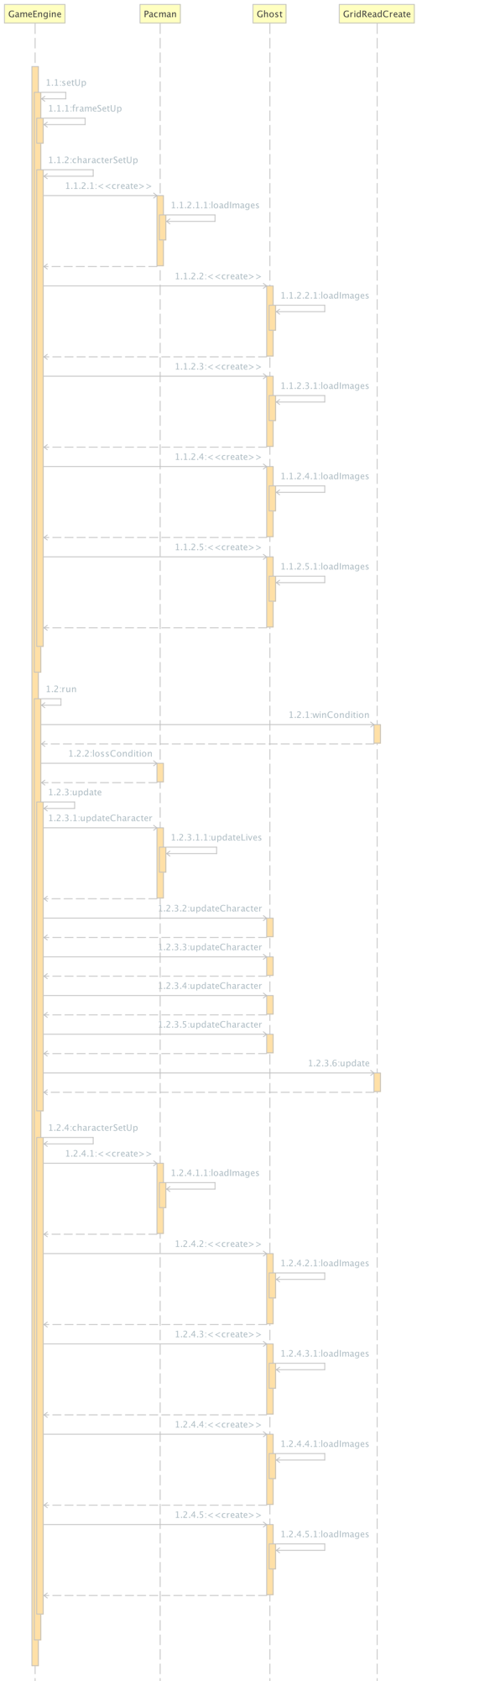

Figure 1. Sequence diagram: Game engine sequence.

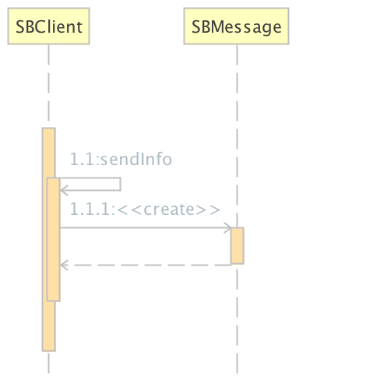

Figure 2. Sequence diagram: Client connects to server.

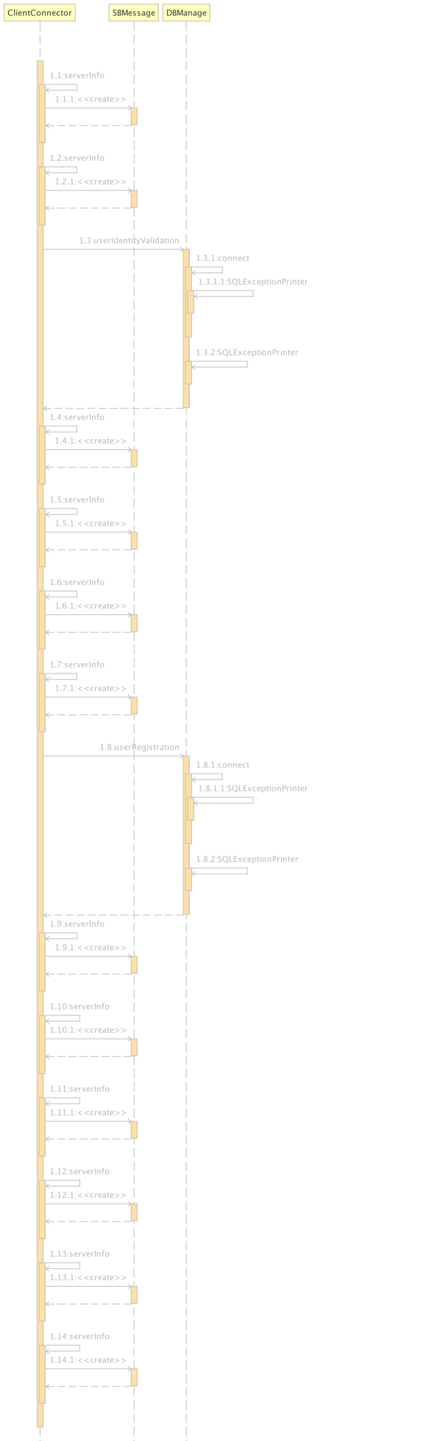

Figure 3. Sequence diagram: Server responses to a client.

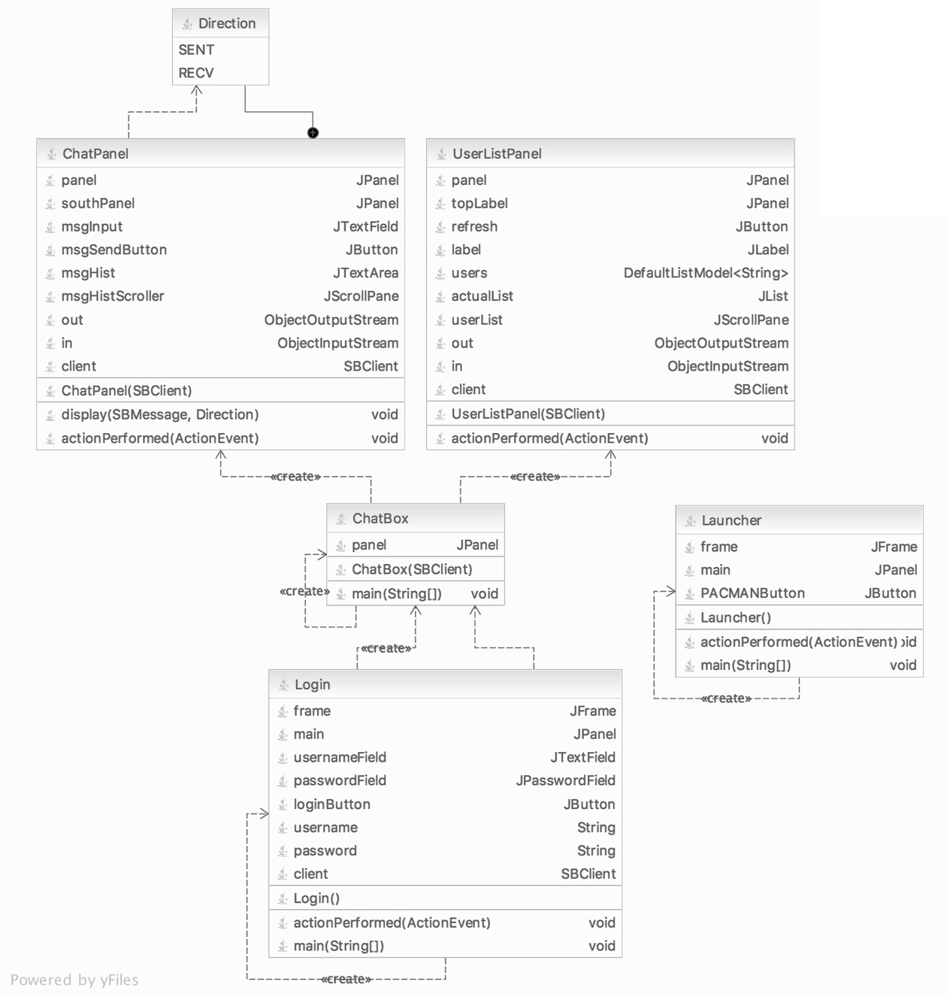

Figure 4. Static class diagram: pacman package.

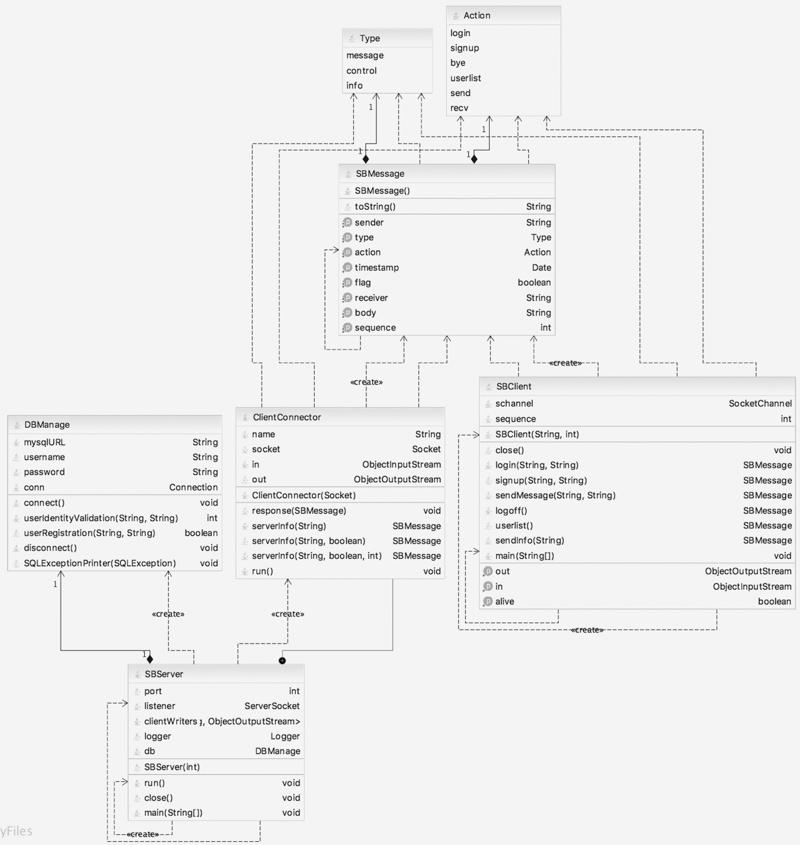

Figure 5. Static class diagram: networking package.

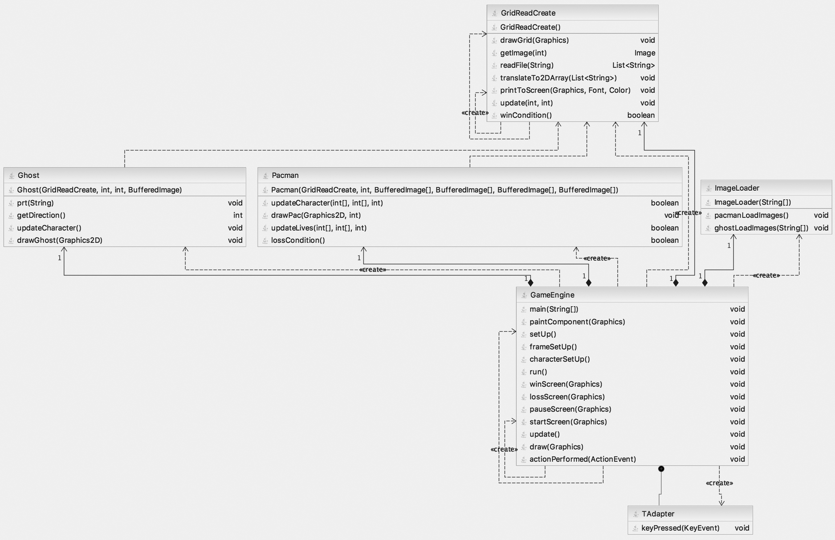

Figure 6. Static class diagram: gui package.

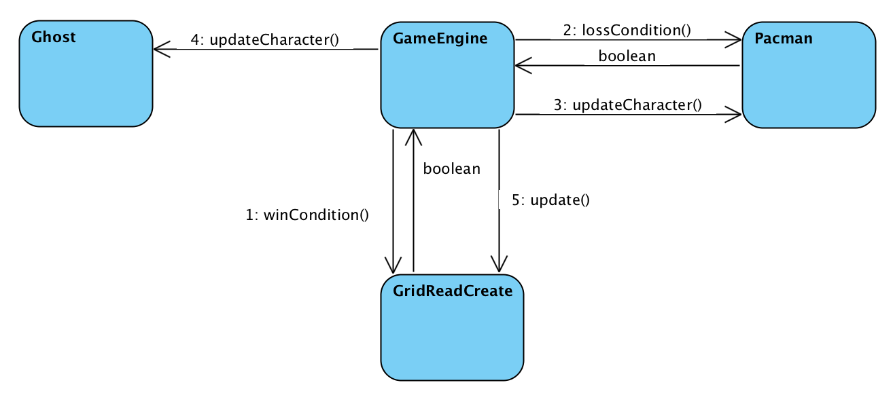

Figure 7. Interaction diagram: Game engine diagram.

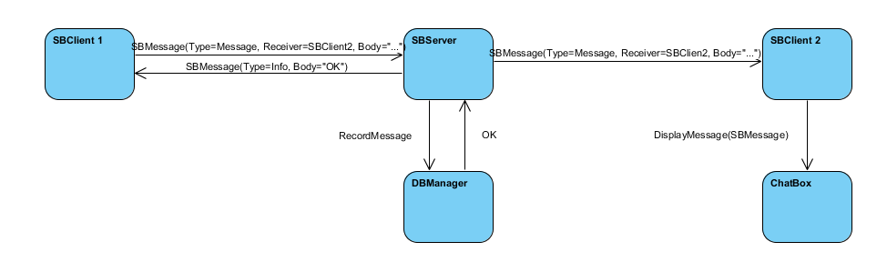

Figure 8. Interaction diagram: Client communication diagram.

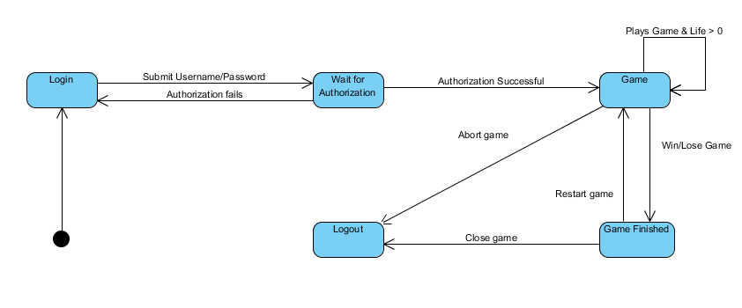

Figure 9. State diagram: Game play state diagram.